Institute of Computer Technology

B. Tech Computer Science and Engineering

Subject: OOP (2CSE303)

**Assignment-4**

**1. Akansha was assigned a task to develop an area calculator with implementation of lambda expression and few specific requirements by the client which are as follows:**

1. **Develop a functional interface to calculate the area of a circle and rectangle.**
2. **Develop a normal interface and implement it to take the user input of radius, length and breadth.**
3. **Display the area of both the shapes.**

***SOLUTION***

package assignment4;

/**

*

* @author YashPrajapati

*/

import java.util.*;

@FunctionalInterface

interface AreaShape {

public void Area();

}

interface Input {

void GetData();

}

public class A4Q1 implements Input {

static int radius, length, breadth;

public void GetData() {

Scanner sc = new Scanner(System.in);

System.out.println("Enter the value of radius: ");

radius = sc.nextInt();

System.out.println("Enter the value of length and breadth: ");

length = sc.nextInt();

breadth = sc.nextInt();

sc.close();

}

public static void main(String[] args) {

A4Q1 obj = new A4Q1();

obj.GetData();

AreaShape a1 = () -> {

System.out.println("\n**********USING LAMBDA EXPRESSION**********");

System.out.println("Area of Circle is: " + (3.14 * radius * radius));

System.out.println("Area of Rectangle is: " + (length * breadth));

};

a1.Area();

System.out.println("");

}

}

***OUTPUT***

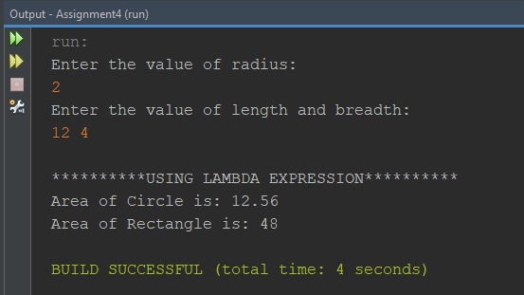

**2. Asha was assigned a task to structure the data using Stack class wherein she was asked to structure the integer values within the stack followed by removal of the top element of the stack along with the retrieval of the top element. Display the size and overall list of elements present within the stack.**

***SOLUTION***

package assignment4;

/**

*

* @author YashPrajapati

*/

import java.util.*;

public class A4Q2 {

public static void main(String[] args) {

Stack<Integer> stackNumber = new Stack<>();

stackNumber.push(10);

stackNumber.push(20);

stackNumber.push(30);

stackNumber.push(40);

stackNumber.push(9274);

System.out.println("Stack => "+(stackNumber));

System.out.println("");

int numAtTop = stackNumber.pop();

System.out.println("stack.pop() => "+numAtTop);

System.out.println("Current Stack => "+(stackNumber));

System.out.println("");

numAtTop = stackNumber.peek();

System.out.println("stack.peek() => "+numAtTop);

System.out.println("Current Stack => "+(stackNumber));

System.out.println("");

System.out.println("Size of Stack is: "+stackNumber.size());

Iterator i = stackNumber.iterator();

System.out.println("Current Stack: ");

while (i.hasNext()) {

System.out.println(i.next());

}

System.out.println("");

}

}

***OUTPUT***

